**Exploration of the yeast metabolism during fermentation through the differential gene expression analysis**

Anna Churkina, Eugenia Ivanova (Strebulaeva)

**Abstract**

Cells maintain their viability and homeostasis in permanently changing conditions by regulation of gene expression. Yeasts are facultative anaerobes and hence are able to adapt to lack of oxygen by switching from aerobic respiration to fermentation. Differential expression analysis is widely used to trace the metabolic changes that follow the conditional changes. In this study we used RNA-sequencing data of Saccharomyces cerevisiae before and during the fermentation process in bread rising to evaluate the differences in RNA expression levels. According to the results supported by information from Saccharomyces Genome Database, a large part of the metabolic pathways was concerned with high significance level. The major changes were observed in expression of the genes responsible for protein biosynthesis, carbohydrate metabolism and response to stresses.

**Introduction**

Among the biological objects, the study of which served as the basis for the development of modern biotechnology, the Saccharomyces yeast is in the lead. Exceptional interest in them is associated with the peculiarities of their metabolism. Saccharomycetes yeast are facultative anaerobes, therefore glucose catabolism in the cell can take place both in aerobic and anaerobic conditions, its main function is the synthesis of ATP. In the framework of the biotechnological process of yeast ethanol synthesis, the second way is most preferable [1-2].

In both cases, glucose is cleaved through a series of enzymatic reactions to form two molecules of pyruvic acid (pyruvate). This process is called glycolysis, or *Embden–Meyerhof–Parnas (EMP) pathway* [3].

In the presence of oxygen, the yeast switches to a significantly more favorable energetically aerobic respiration, in which it produces 20 times more product. Thus, when one glucose molecule is utilized, 36 ATP molecules are formed [4]. This transition is called the Pasteur effect [5].

С6Н12О6 + 6О2 → 6СО2 + 6Н2О + 36ATP

At low oxygen concentrations, the product of glycolysis is pyruvate. The resulting pyruvic acid is decarboxylated with the participation of pyruvate decarboxylase into acetaldehyde with the release of a carbon dioxide molecule. Further, the enzyme alcohol dehydrogenase [6], using two NADH+H+ formed in the oxidative stage, reduces acetaldehyde to ethanol with a low energy yield (2 ATP molecules per one glucose molecule) [7].

С6Н12О6 → 2СО2 + 2СН3СН2ОН

Fermentation efficiency is ~20 % and that part of the energy is mainly dissipated as heat. The fermentation rate is variable, and the highest activity is observed during the first 24–36 hours.

Microarray or transcriptome sequencing (RNA-seq) techniques are now being used to study cellular physiological and pathological changes in detail, and are powerful tools for taking a snapshot of a cell's transcriptome and analyzing differential gene expression.

Thus, the purpose of this project is to analyze the differential expression of genes in order to study in detail the processes of yeast fermentation.

**Materials and methods**

Data

RNA-seq reads in two replicates for the control (before fermentation) and two replicates for the experiment (during fermentation):

SRR941816: fermentation 0 minutes replicate 1

[ftp.sra.ebi.ac.uk/vol1/fastq/SRR941/SRR941816/SRR941816.fastq.gz](http://ftp.sra.ebi.ac.uk/vol1/fastq/SRR941/SRR941816/SRR941816.fastq.gz) (413 Mb)

SRR941817: fermentation 0 minutes replicate 2

[ftp.sra.ebi.ac.uk/vol1/fastq/SRR941/SRR941817/SRR941817.fastq.gz](http://ftp.sra.ebi.ac.uk/vol1/fastq/SRR941/SRR941817/SRR941817.fastq.gz) (455 Mb)

SRR941818: fermentation 30 minutes replicate 1 [ftp.sra.ebi.ac.uk/vol1/fastq/SRR941/SRR941818/SRR941818.fastq.gz](http://ftp.sra.ebi.ac.uk/vol1/fastq/SRR941/SRR941818/SRR941818.fastq.gz) (79.3 Mb)

SRR941819: fermentation 30 minutes replicate 2 [ftp.sra.ebi.ac.uk/vol1/fastq/SRR941/SRR941819/SRR941819.fastq.gz](http://ftp.sra.ebi.ac.uk/vol1/fastq/SRR941/SRR941819/SRR941819.fastq.gz) (282 Mb)  
  
 Reference genome, annotation and transcriptome of Saccharomyces cerevisiae strain S288c and assembly R64 from NCBI:

<http://ftp.ncbi.nlm.nih.gov/genomes/all/GCF/000/146/045/GCF_000146045.2_R64/GCF_000146045.2_R64_genomic.fna.gz>

<http://ftp.ncbi.nlm.nih.gov/genomes/all/GCF/000/146/045/GCF_000146045.2_R64/GCF_000146045.2_R64_genomic.gff.gz>

<https://ftp.ncbi.nlm.nih.gov/genomes/all/GCF/000/146/045/GCF_000146045.2_R64/GCF_000146045.2_R64_rna.fna.gz>

Alignment

Aligning of the reads was performed by the HISAT2 (v. 2.2.1) tool in single-end mode (using two threads). Four resulting bam files were sorted by standard utility.

Quantifying of the features

Before counting the GFF annotation file was converted to GTF format by the gffread tool [8]. To count the features, corresponding to the number of reads for each feature, the featureCounts tool [9] was used with default parameters.

Differential expression analysis

The DESeq2 (v.1.26.0) package [19] for R (v.3.6.3) was used to find differentially expressed genes. The R script for computation of the metrics and drawing plots are shown in Supplementary materials.

Information for the result interpretation

The functions of the differentially expressed genes and concerned pathways were figured out through search in Saccharomyces Genome Database by Gene Ontology terms [10]. These terms are curated keywords that describe gene function.

**Results**

In this project, 6,420 genes were analyzed in four yeasts: 2 replicates before fermentation and 2 replicates after 30 minutes of fermentation, 2508 genes change expression during the fermentation in bread dough (padj < 0.001).

Heatmap imaging of differential gene expression reveals the difference in gene expression between the two experimental samples (before and after fermentation) (Fig.1).

*Figure 1. Heatmap of differential gene expression*

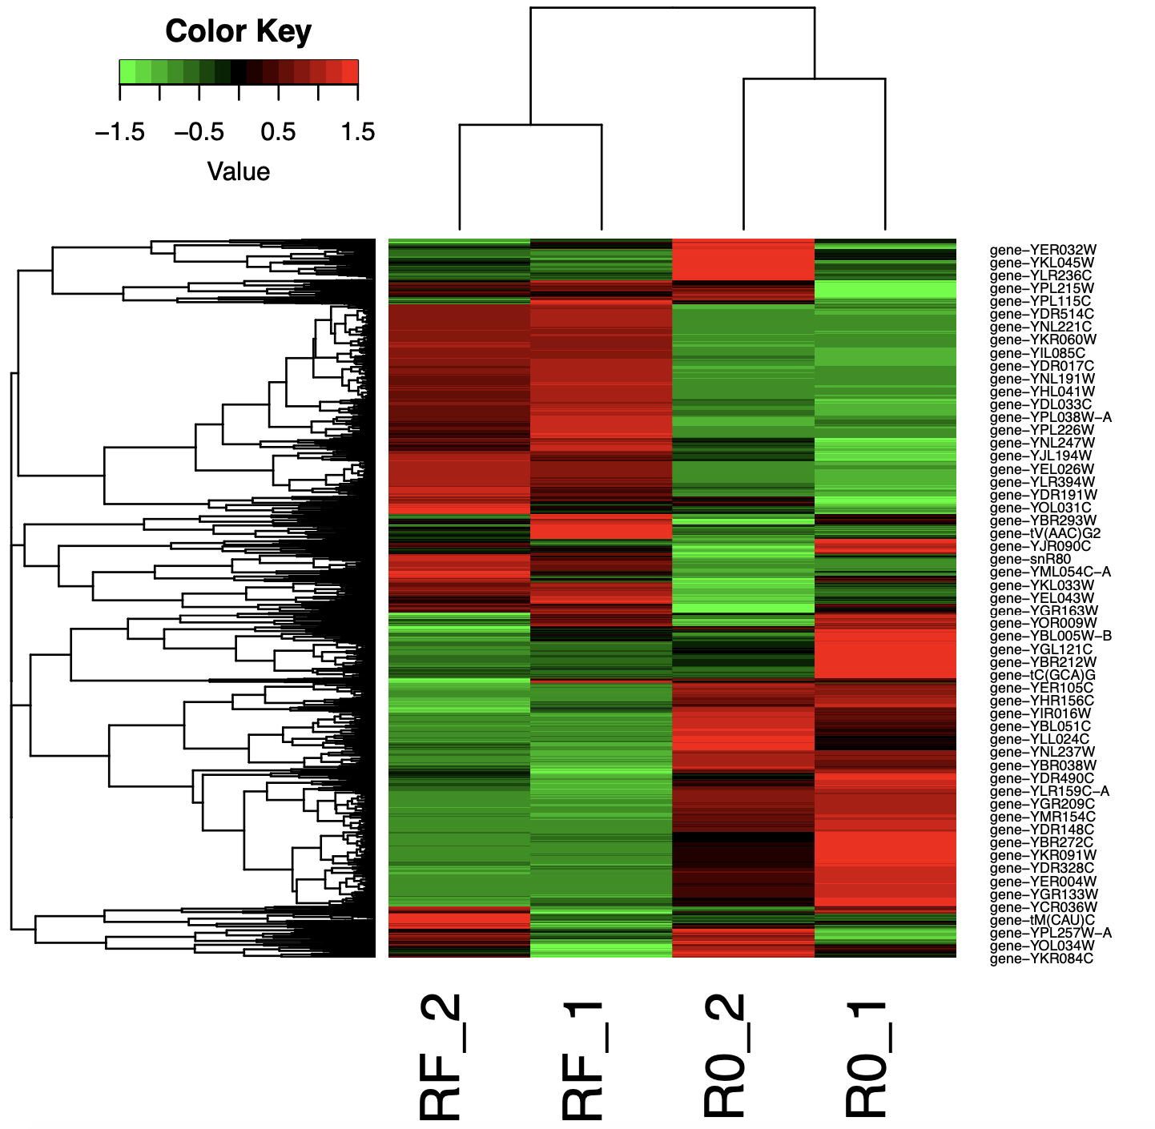

Also, when visualized with volcano-plot (pCutoff = 0.001), a large number of genes are also noted, the expression of which has changed during the fermentation process. It is also observed that the level of expression changes both in the direction of increasing expression, and in the direction of decreasing (Fig.2).

*Figure 2. Volcano-plot of differential gene expression*

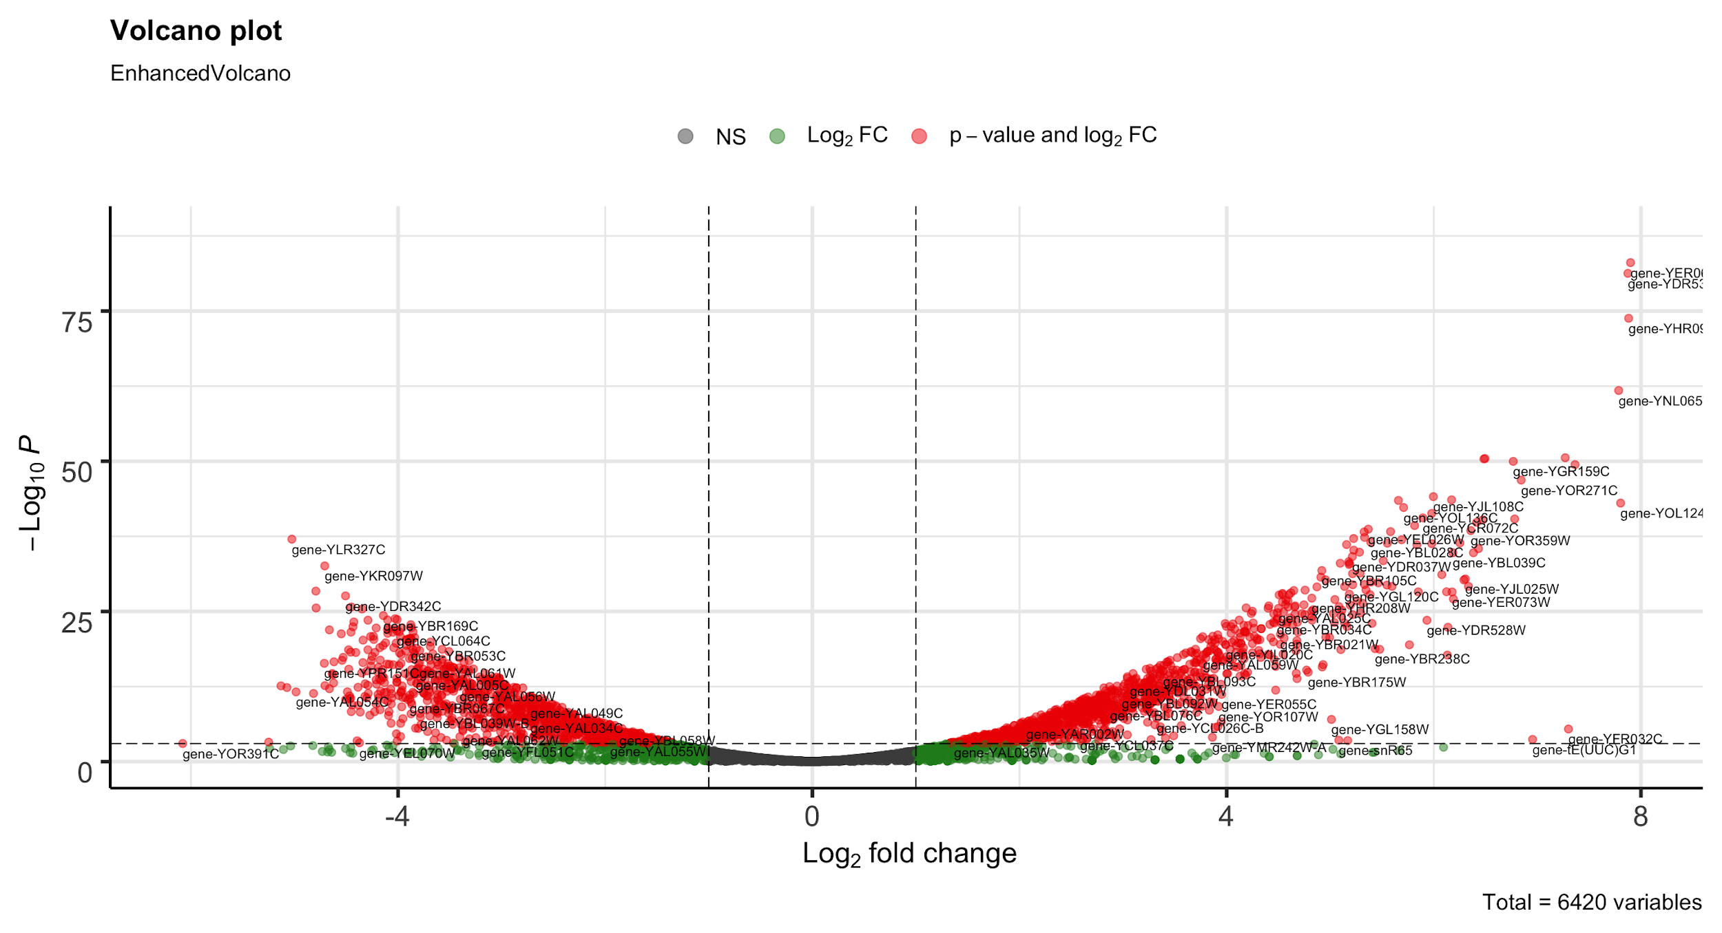

In order to investigate changes in gene expression, the first 50 genes (sorted by adjusted p-values), the expression of which increased as a result of fermentation (Table 1), and 50 genes, the expression of which decreased (Table 2), were examined.

*Table 1. 50 upregulated genes*

|  |  |  |  |  |  |  |
| --- | --- | --- | --- | --- | --- | --- |
| **GO ID** | **TERM** | **NUMLIST ANNOTATIONS** | **CLUSTER FREQUENCY** | **TOTAL NUM ANNOTATIONS** | **GENOME FREQUENCY** | **ANNOTATED GENES** |
| GO:0006364 | rRNA processing | 15 | 30.00% | 366 | 5.68% | YDR449C, YEL026W, YER127W, YGR128C, YGR159C, YHR066W, YHR196W, YJL069C, YKL078W, YLR264W, YMR093W, YNL112W, YNL182C, YOL041C, YOL080C |
| GO:0042274 | ribosomal small subunit biogenesis | 10 | 20.00% | 146 | 2.27% | YDR449C, YEL026W, YER127W, YGR128C, YGR159C, YHR196W, YJL069C, YKL078W, YLR264W, YMR093W |
| GO:0042273 | ribosomal large subunit biogenesis | 9 | 18.00% | 130 | 2.02% | YCR072C, YDL063C, YEL026W, YHR066W, YIR012W, YJL122W, YNL182C, YOL041C, YOL080C |
| GO:0006360 | transcription by RNA polymerase I | 8 | 16.00% | 71 | 1.10% | YGR128C, YHR196W, YJL148W, YJR063W, YKL078W, YML043C, YMR093W, YNL248C |
| GO:0042255 | ribosome assembly | 7 | 14.00% | 79 | 1.23% | YCR072C, YGR159C, YHR066W, YIR012W, YLR264W, YNL182C, YOL080C |
| GO:0006811 | ion transport | 6 | 12.00% | 340 | 5.28% | YDR536W, YHR094C, YKL120W, YNL065W, YNR060W, YOR271C |
| GO:0055085 | transmembrane transport | 5 | 10.00% | 468 | 7.26% | YDR536W, YHR094C, YKL120W, YNL065W, YOR271C |
| GO:0055086 | nucleobase-containing small molecule metabolic process | 4 | 8.00% | 220 | 3.41% | YBL039C, YMR300C, YNL141W, YOL136C |
| GO:0006417 | regulation of translation | 4 | 8.00% | 234 | 3.63% | YER049W, YLR264W, YNL112W, YOR359W |
| GO:0006401 | RNA catabolic process | 4 | 8.00% | 166 | 2.58% | YER049W, YLR264W, YNL112W, YOR359W |
| GO:0015931 | nucleobase-containing compound transport | 3 | 6.00% | 183 | 2.84% | YGR128C, YHR196W, YLR264W |
| GO:0006520 | cellular amino acid metabolic process | 3 | 6.00% | 218 | 3.38% | YBL039C, YLR180W, YMR300C |
| GO:0005975 | carbohydrate metabolic process | 3 | 6.00% | 253 | 3.93% | YBR105C, YER062C, YOL136C |
| GO:0008033 | tRNA processing | 2 | 4.00% | 134 | 2.08% | YOL124C, YPL212C |
| GO:0008643 | carbohydrate transport | 2 | 4.00% | 46 | 0.71% | YDR536W, YHR094C |
| GO:0006353 | DNA-templated transcription, termination | 2 | 4.00% | 42 | 0.65% | YJR063W, YNL112W |
| GO:0006865 | amino acid transport | 2 | 4.00% | 56 | 0.87% | YNL065W, YOR271C |
| GO:0051603 | proteolysis involved in cellular protein catabolic process | 2 | 4.00% | 265 | 4.11% | YBR105C, YLR224W |
| GO:0006352 | DNA-templated transcription, initiation | 2 | 4.00% | 83 | 1.29% | YML043C, YNL248C |
| GO:0006354 | DNA-templated transcription, elongation | 2 | 4.00% | 109 | 1.69% | YJL148W, YNL248C |
| GO:0009451 | RNA modification | 2 | 4.00% | 186 | 2.89% | YOL124C, YPL212C |
| GO:0042221 | response to chemical | 2 | 4.00% | 530 | 8.23% | YLR224W, YNL065W |
| GO:0051052 | regulation of DNA metabolic process | 2 | 4.00% | 97 | 1.51% | YNL182C, YOR359W |
| GO:0006366 | transcription by RNA polymerase II | 2 | 4.00% | 556 | 8.63% | YJR063W, YNL112W |
| GO:0006629 | lipid metabolic process | 2 | 4.00% | 348 | 5.40% | YBL039C, YOL151W |
| GO:0006970 | response to osmotic stress | 1 | 2.00% | 73 | 1.13% | YER062C |
| GO:0006418 | tRNA aminoacylation for protein translation | 1 | 2.00% | 37 | 0.57% | YDR037W |
| GO:0070647 | protein modification by small protein conjugation or removal | 1 | 2.00% | 223 | 3.46% | YLR224W |
| GO:0006310 | DNA recombination | 1 | 2.00% | 255 | 3.96% | YGR159C |
| GO:0008380 | RNA splicing | 1 | 2.00% | 153 | 2.37% | YEL026W |
| GO:0002181 | cytoplasmic translation | 1 | 2.00% | 205 | 3.18% | YLR264W |
| GO:0006873 | cellular ion homeostasis | 1 | 2.00% | 162 | 2.51% | YNR060W |
| GO:0032787 | monocarboxylic acid metabolic process | 1 | 2.00% | 164 | 2.55% | YOL136C |
| GO:0006260 | DNA replication | 1 | 2.00% | 151 | 2.34% | YNL182C |
| GO:0033043 | regulation of organelle organization | 1 | 2.00% | 279 | 4.33% | YLR180W |
| GO:0018193 | peptidyl-amino acid modification | 1 | 2.00% | 256 | 3.97% | YER049W |
| GO:0006605 | protein targeting | 1 | 2.00% | 256 | 3.97% | YBR105C |
| GO:0006091 | generation of precursor metabolites and energy | 1 | 2.00% | 113 | 1.75% | YOL136C |
| GO:0070925 | organelle assembly | 1 | 2.00% | 125 | 1.94% | YLR180W |
| GO:0006397 | mRNA processing | 1 | 2.00% | 220 | 3.41% | YEL026W |

*Table 2. 50 downregulated genes*

|  |  |  |  |  |  |  |
| --- | --- | --- | --- | --- | --- | --- |
| **GO ID** | **TERM** | **NUMLIST ANNOTATIONS** | **CLUSTER FREQUENCY** | **TOTAL NUM ANNOTATIONS** | **GENOME FREQUENCY** | **ANNOTATED GENES** |
| GO:0005975 | carbohydrate metabolic process | 13 | 26.00% | 253 | 3.93% | YBR053C, YBR149W, YCL040W, YEL011W, YFR015C, YIL155C, YIL162W, YKL085W, YKR097W, YLR174W, YNL117W, YNR001C, YPR184W |
| GO:0032787 | monocarboxylic acid metabolic process | 7 | 14.00% | 164 | 2.55% | YCL040W, YKL182W, YLR174W, YNL117W, YNR016C, YPL231W, YPR006C |
| GO:0045333 | cellular respiration | 7 | 14.00% | 116 | 1.80% | YKL085W, YKL109W, YLR174W, YLR304C, YMR081C, YNL117W, YNR001C |
| GO:0042221 | response to chemical | 7 | 14.00% | 530 | 8.23% | YCR021C, YDR171W, YDR216W, YGR008C, YKL109W, YNL173C, YOL016C |
| GO:0006457 | protein folding | 7 | 14.00% | 121 | 1.88% | YBR072W, YBR169C, YDR171W, YMR186W, YNL077W, YOR027W, YPL240C |
| GO:0006629 | lipid metabolic process | 7 | 14.00% | 348 | 5.40% | YGR157W, YJR073C, YKL182W, YLR133W, YNR016C, YPL231W, YPR006C |
| GO:0055085 | transmembrane transport | 6 | 12.00% | 468 | 7.26% | YCL040W, YCR021C, YDR342C, YDR343C, YLR411W, YNL055C |
| GO:0009408 | response to heat | 6 | 12.00% | 67 | 1.04% | YBR072W, YCR021C, YDR171W, YMR186W, YPL004C, YPL240C |
| GO:0006811 | ion transport | 5 | 10.00% | 340 | 5.28% | YCR021C, YDR342C, YDR343C, YLR411W, YNL055C |
| GO:0007005 | mitochondrion organization | 4 | 8.00% | 287 | 4.45% | YLR304C, YNL055C, YOR027W, YPL240C |
| GO:0006091 | generation of precursor metabolites and energy | 4 | 8.00% | 113 | 1.75% | YCL040W, YEL011W, YFR015C, YPR184W |
| GO:0006468 | protein phosphorylation | 4 | 8.00% | 237 | 3.68% | YBR214W, YNL055C, YOL016C, YPL004C |
| GO:0006897 | endocytosis | 3 | 6.00% | 136 | 2.11% | YBR214W, YNL194C, YPL004C |
| GO:0055086 | nucleobase-containing small molecule metabolic process | 3 | 6.00% | 220 | 3.41% | YCL040W, YNR001C, YNR016C |
| GO:0006970 | response to osmotic stress | 3 | 6.00% | 73 | 1.13% | YCR021C, YDR171W, YPL240C |
| GO:0008643 | carbohydrate transport | 3 | 6.00% | 46 | 0.71% | YCL040W, YDR342C, YDR343C |
| GO:0006979 | response to oxidative stress | 3 | 6.00% | 130 | 2.02% | YCR021C, YDR171W, YOL016C |
| GO:0031399 | regulation of protein modification process | 3 | 6.00% | 208 | 3.23% | YBR214W, YNL055C, YPL004C |
| GO:0006605 | protein targeting | 2 | 4.00% | 256 | 3.97% | YOR027W, YPL240C |
| GO:0033043 | regulation of organelle organization | 2 | 4.00% | 279 | 4.33% | YBR214W, YPL240C |
| GO:0071554 | cell wall organization or biogenesis | 2 | 4.00% | 299 | 4.64% | YNL194C, YOL155C |
| GO:0007010 | cytoskeleton organization | 2 | 4.00% | 278 | 4.31% | YDR171W, YNL194C |
| GO:0006366 | transcription by RNA polymerase II | 2 | 4.00% | 556 | 8.63% | YDR216W, YKL109W |
| GO:0032200 | telomere organization | 2 | 4.00% | 93 | 1.44% | YMR186W, YPL240C |
| GO:0051052 | regulation of DNA metabolic process | 1 | 2.00% | 97 | 1.51% | YPL240C |
| GO:0042594 | response to starvation | 1 | 2.00% | 86 | 1.33% | YBR214W |
| GO:0006520 | cellular amino acid metabolic process | 1 | 2.00% | 218 | 3.38% | YCL064C |
| GO:0048284 | organelle fusion | 1 | 2.00% | 112 | 1.74% | YNL015W |
| GO:0007031 | peroxisome organization | 1 | 2.00% | 52 | 0.81% | YDR216W |
| GO:0006766 | vitamin metabolic process | 1 | 2.00% | 57 | 0.88% | YBR053C |
| GO:0048285 | organelle fission | 1 | 2.00% | 272 | 4.22% | YBR214W |
| GO:0051726 | regulation of cell cycle | 1 | 2.00% | 295 | 4.58% | YBR214W |
| GO:0006325 | chromatin organization | 1 | 2.00% | 304 | 4.72% | YDR216W |
| GO:0043934 | sporulation | 1 | 2.00% | 170 | 2.64% | YNL194C |
| GO:0070647 | protein modification by small protein conjugation or removal | 1 | 2.00% | 223 | 3.46% | YNL077W |
| GO:0007059 | chromosome segregation | 1 | 2.00% | 222 | 3.45% | YBR214W |
| GO:0051049 | regulation of transport | 1 | 2.00% | 100 | 1.55% | YNL055C |
| GO:0006873 | cellular ion homeostasis | 1 | 2.00% | 162 | 2.51% | YLR411W |
| GO:0007033 | vacuole organization | 1 | 2.00% | 113 | 1.75% | YNL015W |
| GO:0000278 | mitotic cell cycle | 1 | 2.00% | 376 | 5.84% | YBR214W |
| GO:0051604 | protein maturation | 1 | 2.00% | 96 | 1.49% | YPL240C |
| GO:0009311 | oligosaccharide metabolic process | 1 | 2.00% | 30 | 0.47% | YIL162W |
| GO:0051321 | meiotic cell cycle | 1 | 2.00% | 323 | 5.01% | YNL194C |
| GO:0006470 | protein dephosphorylation | 1 | 2.00% | 101 | 1.57% | YBR214W |
| GO:0051603 | proteolysis involved in cellular protein catabolic process | 1 | 2.00% | 265 | 4.11% | YBR169C |
| GO:0015931 | nucleobase-containing compound transport | 1 | 2.00% | 183 | 2.84% | YNL055C |
| GO:0006974 | cellular response to DNA damage stimulus | 1 | 2.00% | 226 | 3.51% | YCR021C |
| GO:0018193 | peptidyl-amino acid modification | 1 | 2.00% | 256 | 3.97% | YNL077W |
| GO:0000746 | conjugation | 1 | 2.00% | 119 | 1.85% | YNL173C |

**Discussion**

In the metabolism of yeast and all living systems in general, carbohydrates are of great importance. The breakdown of carbohydrates/sugars (glycolysis) is one of the main processes. This process produces energy for physiological processes and for the biological synthesis of many substances. In the absence of oxygen, yeast cells reconstruct their metabolism in order to utilize carbohydrates by other metabolic pathways. This study was aimed to understand what processes occur in yeast cells during fermentation. In the process of studying differential genes expression in *Saccharomyces cerevisiae* the most significant genes whose expression changes during yeast fermentation were identified (Table 3).

*Table 3. The most significant genes for yeast fermentation*

|  |  |  |
| --- | --- | --- |
| **Annotated gene** | **Name** | **Function** |
| Upregulated | | |
| GO terms: Carbohydrate metabolic process, carbohydrate transport | | |
| YBR105C | VID24 | GID Complex regulatory subunit; binds GID Complex in response to glucose through interactions with complex member Vid28p; regulates fructose-1,6-bisphosphatase (FBPase) targeting to the vacuole; promotes proteasome-dependent catabolite degradation of FBPase |
| YOL136C | PFK27 | 6-phosphofructo-2-kinase; catalyzes synthesis of fructose-2,6-bisphosphate; inhibited by phosphoenolpyruvate and sn-glycerol 3-phosphate, expression induced by glucose and sucrose |
| YHR094C | HXT1 | Low-affinity glucose transporter of the major facilitator superfamily; expression is induced by Hxk2p in the presence of glucose and repressed by Rgt1p when glucose is limiting; HXT1 has a paralog, HXT6, what arose from the whole genome duplication |
| GO terms: response to osmotic stress, response to oxidative stress, transmembrane transport | | |
| YER062C | GPP2 | DL-glycerol-3-phosphate phosphatase involved in glycerol biosynthesis; also known as glycerol-1-phosphatase; induced in response to hyperosmotic or oxidative stress, and during diauxic shift |
| YDR536W | STL1 | Glycerol proton symporter of the plasma membrane; subject to glucose-induced inactivation, strongly but transiently induced when cells are subjected to osmotic shock |
| YNL065W | AQR1 | Plasma membrane transporter of the major facilitator superfamily; member of the 12-spanner drug:H(+) antiporter DHA1 family; confers resistance to short-chain monocarboxylic acids and quinidine; involved in the excretion of excess amino acids; AQR1 has a paralog, QDR1, that arose from the whole genome duplication; relocalizes from plasma membrane to cytoplasm upon DNA replication stress |
| Downregulated | | |
| GO terms: carbohydrate metabolic process | | |
| YIL162W | SUC2 | Invertase; sucrose hydrolyzing enzyme; a secreted, glycosylated form is regulated by glucose repression, and an intracellular, nonglycosylated enzyme is produced constitutively |
| YKR097W | PCK1 | Phosphoenolpyruvate carboxykinase; key enzyme in gluconeogenesis, catalyzes early reaction in carbohydrate biosynthesis, glucose represses transcription and accelerates mRNA degradation, regulated by Mcm1p and Cat8p, located in the cytosol |
| YEL011W | GLC3 | Glycogen branching enzyme, involved in glycogen accumulation; green fluorescent protein (GFP)-fusion protein localizes to the cytoplasm in a punctate pattern; relocalizes from nucleus to cytoplasmic foci upon DNA replication stress; glycogen accumulation defect of the null mutant is functionally complemented by human GBE1, which is associated with glycogen storage disease |
| YFR015C | GSY1 | Glycogen synthase; expression induced by glucose limitation, nitrogen starvation, environmental stress, and entry into stationary phase; GSY1 has a paralog, GSY2, that arose from the whole genome duplication; relocalizes from nucleus to cytoplasmic foci upon DNA  replication stress |
| YPR184W | GDB1 | Glycogen debranching enzyme; contains glucanotranferase and alpha-1,6-amyloglucosidase activities; required  for glycogen degradation; phosphorylated in mitochondria; activity is inhibited by Igd1p; protein abundance increases in response to DNA replication stress |
| YDR342C | HXT7 | High-affinity glucose transporter; member of the  major facilitator superfamily, nearly identical to Hxt6p, expressed at high basal levels relative to other HXTs, expression repressed by high glucose levels; HXT7 has a paralog, HXT4, that arose from the whole genome duplication |
| YDR343C | HXT6 | High-affinity glucose transporter; member of the major facilitator superfamily, nearly identical to Hxt7p, expressed at high basal levels relative to other HXTs, repression of expression by high glucose requires SNF3; HXT6 has a paralog, HXT1, that arose from the whole genome duplication |
| GO terms: cellular respiration | | |
| YKL085W | MDH1 | Mitochondrial malate dehydrogenase; catalyzes interconversion of malate and oxaloacetate; involved in the tricarboxylic acid (TCA) cycle; phosphorylated; mutation in human homolog MDH2 causes early-onset severe encephalopathy |
| YLR174W | IDP2 | Cytosolic NADP-specific isocitrate dehydrogenase; catalyzes oxidation of isocitrate to alpha-ketoglutarate; levels are elevated during growth on non-fermentable carbon sources and reduced during growth on glucose; IDP2 has a paralog, IDP3, that arose from the whole genome duplication; mutation in human homolog IDH1 is associated with low-grade gliomas and secondary glioblastomas |
| YNL117W | MLS1 | Malate synthase, enzyme of the glyoxylate cycle; involved in utilization of non-fermentable carbon sources; expression is subject to carbon catabolite repression; localizes in peroxisomes during growth on oleic acid, otherwise cytosolic; can accept butyryl-CoA as acyl-CoA donor in addition to traditional substrate acetyl-CoA |
| YNR001C | CIT1 | Mitochondrial citrate synthase; catalyzes condensation of acetyl coenzyme A and oxaloacetate to form citrate, which is the first and rate-limiting step of the TCA cycle; transcription subject to glucose repression; CIT1 has a paralog, CIT2, that arose from the whole genome duplication |
| YKL109W | HAP4 | Transcription factor; subunit of the heme-activated, glucose-repressed Hap2p/3p/4p/5p CCAAT-binding complex, a transcriptional activator and global regulator of respiratory gene expression; provides the principal activation function of the complex; involved in diauxic shift |
| YLR304C | ACOI | Aconitase; required for the tricarboxylic acid (TCA) cycle and also independently required for mitochondrial genome maintenance; component of the mitochondrial nucleoid; mutation leads to glutamate auxotrophy; mutation in human homolog ACO2 is associated with dominant optic nerve atrophy; human homolog ACO2 can complement yeast null mutant |

Embedded in the nourishing dough the yeasts adapt and start to grow, utilizing carbohydrates. The active growth of yeast is confirmed by the activation of genes responsible for protein synthesis. From the results of the differential expression analysis can be seen that the most upregulated genes are involved in transcription, RNA processing, ribosome biosynthesis and translation (see Table 1).

A feature of fermentation in the production of bakery products is a high concentration of carbohydrates / sugars (especially when baking sweet bread). High glucose level increases synthesis of the glycolysis enzymes, regulator and low-affinity transport proteins, such as products of PFK27, VID24 and HXT1 genes. Conversely, levels of the carbohydrate synthesis enzymes are decreased, as shown in Table 2 and 3. The downregulated gene PCK1 encodes a key enzyme in gluconeogenesis, genes GLC3 and GSY1 are responsible for glycogen synthesis. Cells primarily utilizes more accessible energy sources (and glucose concentration is very high), so the genes SUC2 and GBD1 - sucrose hydrolyzing enzyme and glycogen debranching enzyme - are downregulated. Besides, as a consequence of the high glucose levels inside the cells, genes of high-affinity transporter proteins HXT6 and HXT7 are downregulated, and this is consistent with previous study of activation of HXT7 gene on high-glucose medium [11].

After 30 minutes of fermentation many genes, involved in carbohydrate metabolic processes, respiration, TCA cycle and oxidative phosphorylation, changed levels of expression. In the absence of oxygen aerobic respiration is inhibited and the results confirm it by downregulation of the MDH1, IDP2, MLS1, CIT1 and ACO1 genes which encode mitochondrial enzymes of the respiration process, and HAP4 - transcription factor that regulates respiratory gene expression.

During fermentation, yeast undergoes various types of physical and chemical stress, which include hyperosmotic, ethanol, oxidative, and carbon dioxide stress. In addition to changes in carbohydrate metabolism, high sugar content exerts strong osmotic pressure on yeast, which also affects its enzymatic activity. The response to changes in osmotic pressure was studied in laboratory yeast strains and it was found that yeast cells experience osmotic stress [12]. The response of yeast cells to osmotic stress depends on the density of the medium and its carbohydrate composition, the physiological state of the yeast, and the stage of cell growth. Reproducing cells (log-phase of growth) are more sensitive to stress than cells in the stationary phase of growth. This is due to the different chemical composition of yeast, in particular, the content of reserve carbohydrates in it. At the genetic level, the response to a highly osmotic environment manifests itself in the form of a change in the expression of many genes that regulate metabolic processes (protein and carbohydrate), redox reactions, permeability of cell membranes, as well as genes responsible for resistance to osmotic changes [13-14].

Also, fermentation in dough differs from liquid fermentation by small amounts of free water. Therefore, cell movement and diffusion of the metabolites and nutrients are limited. To prevent dehydration, yeast cells accumulate and synthesize glycerol [15]. We observed overexpression of the genes GPP2 and STL1, which involved in glycerol metabolism and referred to as components of carbohydrate metabolic processes and response to osmotic stress. Also, the AQR1 gene, mediator of the amino acid excretion, was upregulated [16]. The amino acid excretion activates in the overproduction conditions and activation of the AQR1 may be connected with high nutrient concentrations inside of the cells during fermentation.

Our results are consistent with the results of Aslankoohi et al. and Pérez-Torrado et al. where differential expression in baker’s yeasts was studied on several stages of the fermentation [17-18].

**References**

1. Palagina K.K. Tekhnologicheskiye raschety drozhzhevogo proizvodstva [Process estimation of yeast production]. Moscow, 2008.
2. Azhar SHM, Abdulla R, Jambo SA, Marbawi H, Gansau JA, Faik AAM, Rodrigues KF. Yeasts in sustainable bioethanol production: a review. *Biochemistry and Biophysics Reports* 2017; 10: 52-61. https://doi.org/10.1016/j.bbrep.2017.03.003.
3. Kim BH, Gadd GM. (2011) Bacterial Physiology and Metabolism, 3rd edition.
4. Lehninger, Albert. Principles of Biochemistry — New York, NY: [W.H. Freeman and Company](https://en.wikipedia.org/wiki/W._H._Freeman_and_Company), 2008.
5. BARKER, J., KHAN, M. & SOLOMOS, T. Mechanism of the Pasteur Effect. Nature 201, 1126–1127 (1964). https://doi.org/10.1038/2011126a0.
6. Raj SB, Ramaswamy S, Plapp BV. ["Yeast alcohol dehydrogenase structure and catalysis"](https://www.ncbi.nlm.nih.gov/pmc/articles/PMC4165444). Biochemistry. 53: 5791-803. [doi](https://en.wikipedia.org/wiki/Doi_(identifier)):[10.1021/bi5006442](https://doi.org/10.1021%2Fbi5006442). [PMC](https://en.wikipedia.org/wiki/PMC_(identifier)) [4165444](https://www.ncbi.nlm.nih.gov/pmc/articles/PMC4165444).
7. Maicas S. The Role of Yeasts in Fermentation Processes. Microorganisms. 2020;8(8):1142. Published 2020 Jul 28. doi:10.3390/microorganisms8081142.
8. Pertea G and Pertea M. GFF Utilities: GffRead and GffCompare. F1000Research 2020, 9:304 DOI: 10.12688/f1000research.23297.1
9. Liao Y, Smyth GK, Shi W. featureCounts: an efficient general-purpose program for assigning sequence reads to genomic features. Bioinformatics. 2014 Apr 1;30(7):923-30. doi: 10.1093/bioinformatics/btt656. Epub 2013 Nov 13. PMID: 24227677.
10. Cherry JM, Hong EL, Amundsen C, Balakrishnan R, Binkley G, Chan ET, Christie KR, Costanzo MC, Dwight SS, Engel SR, Fisk DG, Hirschman JE, Hitz BC, Karra K, Krieger CJ, Miyasato SR, Nash RS, Park J, Skrzypek MS, Simison M, Weng S, Wong ED (2012) Saccharomyces Genome Database: the genomics resource of budding yeast. Nucleic Acids Res. Jan;40(Database issue):D700-5. [PMID: 22110037].
11. Ye L, Berden JA, van Dam K, Kruckeberg AL. Expression and activity of the Hxt7 high-affinity hexose transporter of Saccharomyces cerevisiae. Yeast. 2001 Sep 30;18(13):1257-67. doi: 10.1002/yea.771. PMID: 11561293.
12. Hohmann S. Osmotic stress signaling and osmoadaptation in yeasts. Microbiol Mol Biol Rev. 2002;66:300–372. doi: 10.1128/MMBR.66.2.300-372.2002.
13. Gasch AP, Spellman PT, Kao CM, Carmel-Harel O, Eisen MB, Storz G, Botstein D, Brown PO. Genomic expression programs in the response of yeast cells to environmental changes. Mol Biol Cell. 2000;11:4241–4257.
14. Causton HC, Ren B, Koh SS, Harbison CT, Kanin E, Jennings EG, Lee TI, True HL, Lander ES, Young RA. Remodeling of yeast genome expression in response to environmental changes. Mol Biol Cell. 2001;12:323–337.
15. Aslankoohi E, Rezaei MN, Vervoort Y, Courtin CM, Verstrepen KJ (2015) Glycerol Production by Fermenting Yeast Cells Is Essential for Optimal Bread Dough Fermentation. PLOS ONE 10(3): e0119364. https://doi.org/10.1371/journal.pone.0119364
16. Velasco I, Tenreiro S, Calderon IL, André B. Saccharomyces cerevisiae Aqr1 is an internal-membrane transporter involved in excretion of amino acids. Eukaryot Cell. 2004;3(6):1492-1503. doi:10.1128/EC.3.6.1492-1503.2004.
17. Aslankoohi E, Zhu B, Rezaei MN, et al. Dynamics of the Saccharomyces cerevisiae transcriptome during bread dough fermentation. Appl Environ Microbiol. 2013;79(23):7325-7333. doi:10.1128/AEM.02649-13.
18. Pérez-Torrado R, Panadero J, Hernández-López MJ, Prieto JA, Randez-Gil F. Global expression studies in baker's yeast reveal target genes for the improvement of industrially-relevant traits: the cases of CAF16 and ORC2. Microb Cell Fact. 2010;9:56. Published 2010 Jul 13. doi:10.1186/1475-2859-9-56.
19. http://bioconductor.org/packages/release/bioc/vignettes/DESeq2/inst/doc/DESeq2.html